Click “Download OpenVPN_Server_Linux.zip
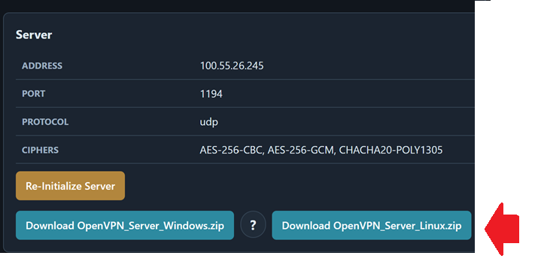
Transfer Zip file to your Linux machine that will be your OpenVPN server
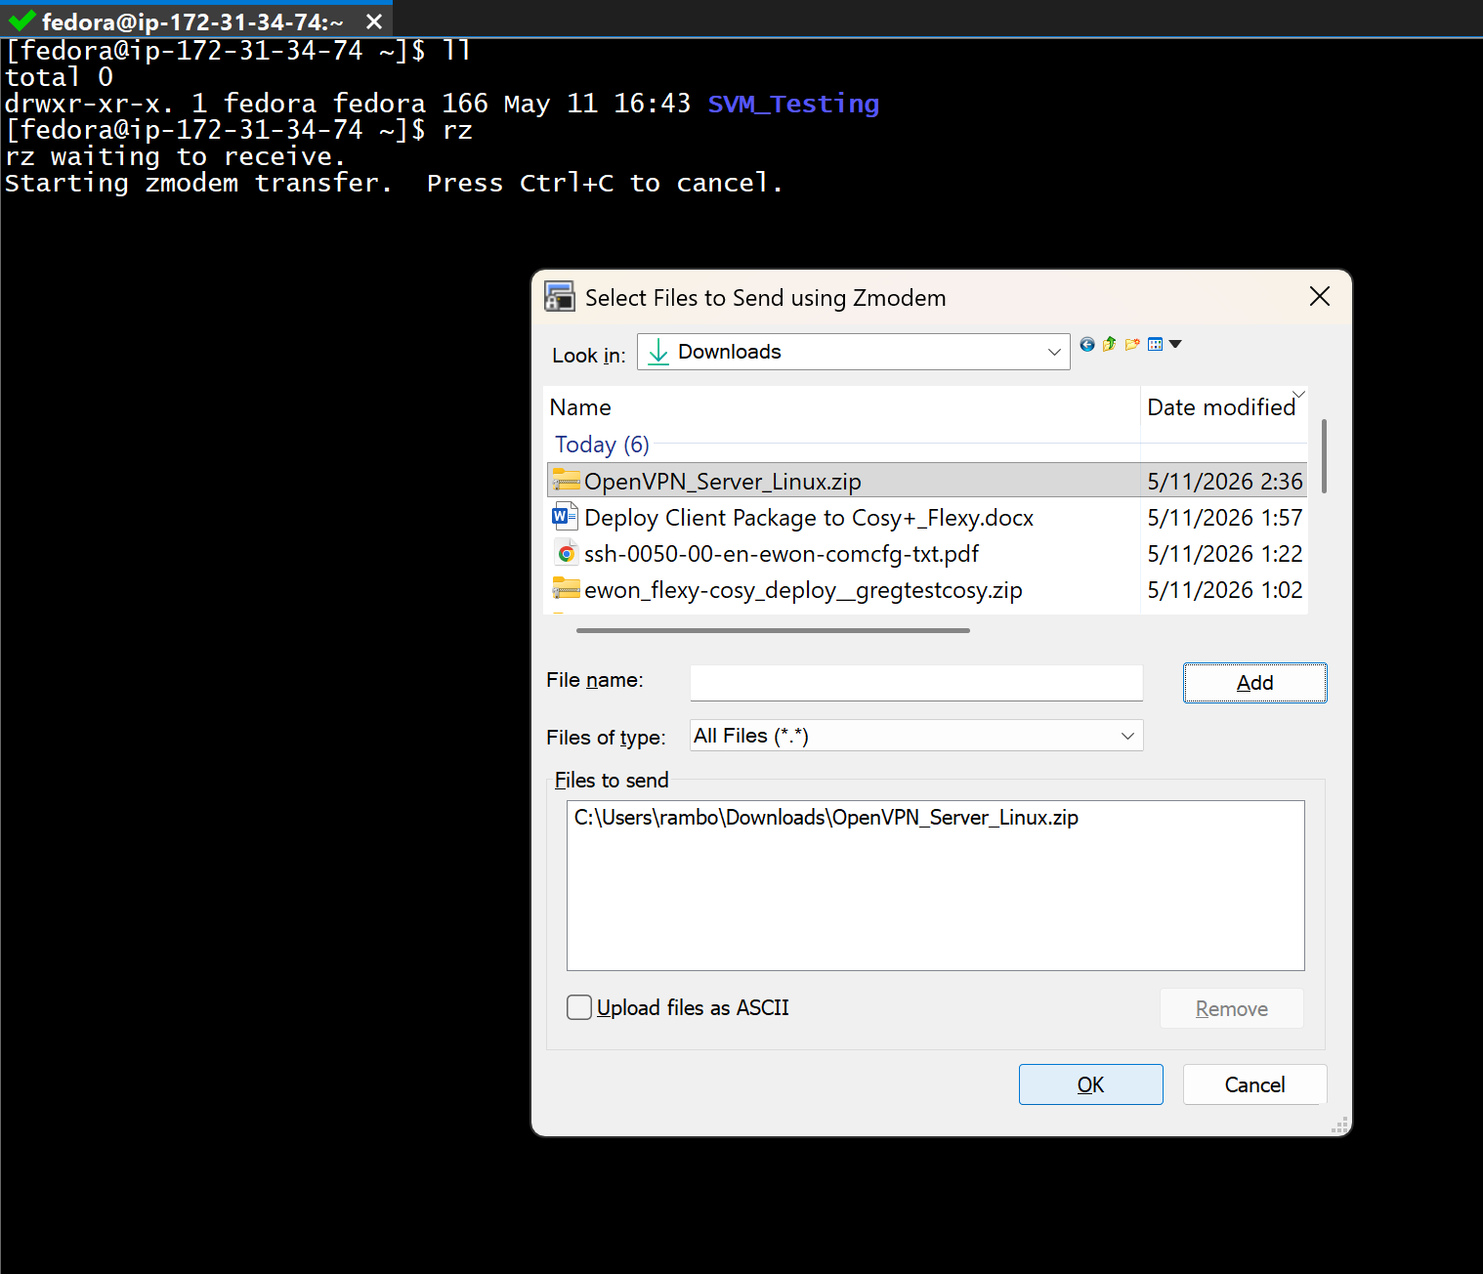
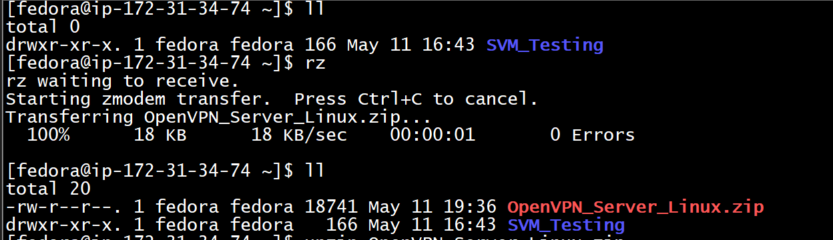
Extract the ZIP file.
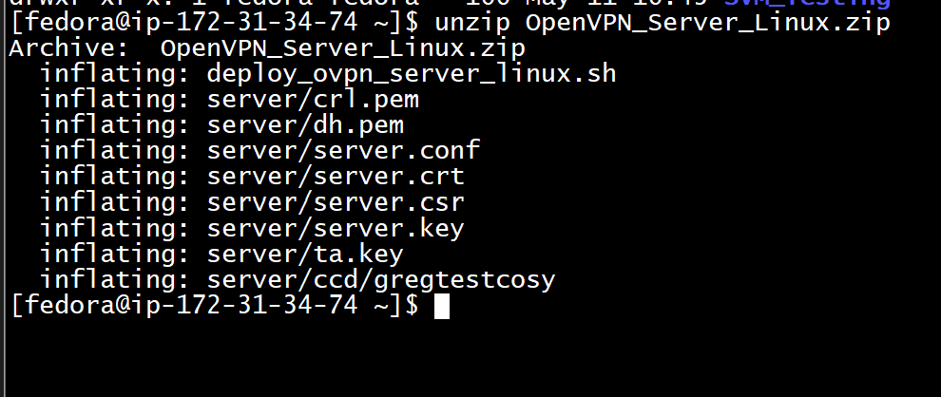
Make sure the shell script is executable by running ‘chmod +x deploy_ovpn_server_linux.sh’
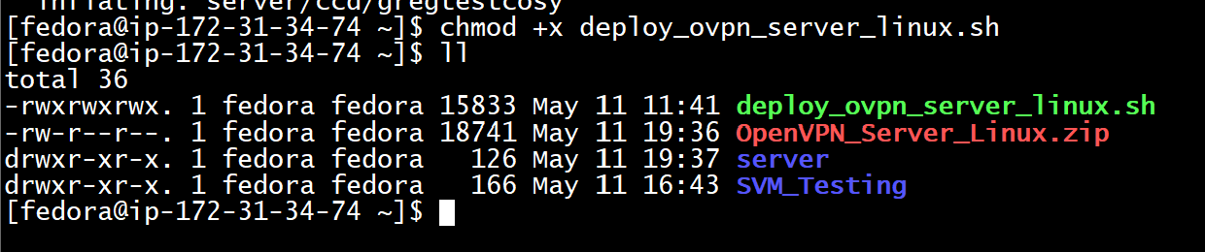
Execute the script by running ‘sudo ./deploy_ovpn_server_linux.sh’
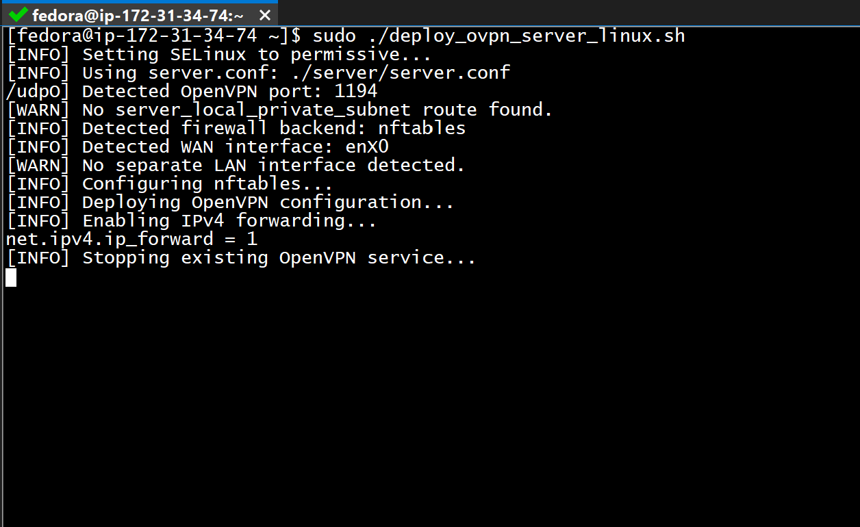

If the script completes without errors, the OpenVPN server deployment was successful
Supported Linux distributions:
- Fedora
- Red Hat
- Debian
- Ubuntu
Supported firewall frameworks:
- FirewallD
- IPTables
- UFW
- NFTables

